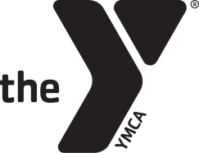Naugatuck YMCA
NOW HIRING AND SEEKING PROGRAM VOLUNTEERS!
LIFEGUARDS AND AQUATICS INSTRUCTORS
Naugatuck YMCA

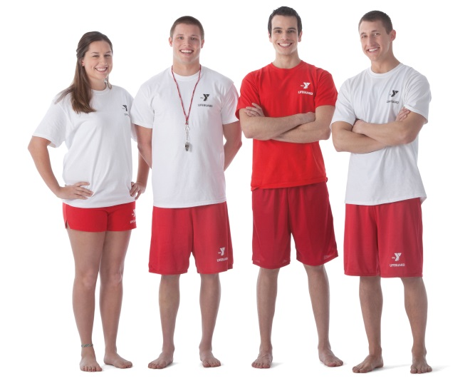
The Aquatics Department is looking to change the lives of youth in our community by hiring dependable, detail oriented, LIFEGUARDS and SWIM INSTRUCTORS that enjoy working with children and families. This position requires responsible people who can create safe and fun environments for our members and program participants.

APPLY TODAY by calling Amanda Michels (203) 729-9622 or filling out an application at the front desk.

